

| Phone Museum | |
| --- | --- |
| App | |
| Project Plan | |
| **Academic year** | 2024/2025 |
| **Teaching Staff** | João Varajão |
| **Degree** | Master's in Telecommunications and Computer Engineering |
| **Year** | 2nd Year |
| **Curricular Unit** | Gestão de Projetos de Tecnologias de Informação |



# The Team

|  | Catarina da Cunha Malheiro da Silva Pereira PG53733  [pg53733@alunos.uminho.pt](mailto:pg53733@alunos.uminho.pt)  Braga, Portugal |
| --- | --- |
|  | Inês Cabral Neves PG53864  [pg53864@alunos.uminho.pt](mailto:pg53864@alunos.uminho.pt)  Porto, Portugal |
|  | Leonardo Dias Martins PG53996  [pg53996@alunos.uminho.pt](mailto:pg53996@alunos.uminho.pt)  Aveiro, Portugal |
|  | Rodrigo Rocha del Castillo E12165  [e12165@alunos.uminho.pt](mailto:e12165@alunos.uminho.pt)  Santander, Spain |





| table of contents | **The Team 03 _________________________________ 01** |
| --- | --- |
| **Table of Contents _____________________________ 02** |
| **List of Tables ________________________________ 03** |
| **List of Figures & Graph_________________________ 04** |
| 1. **Executive Summary _____________________05** |
| 1. **Scope ________________________________06**    1. **Project Purpose ________________06**    2. **Deliverables ___________________06**    3. **Requirements __________________06**    4. **Restrictions ___________________08**    5. **Assumptions ___________________08**    6. **No Scope _____________________09** |
| **3. Stakeholders _________________________ 10**   * 1. **Stakeholders List ______________ 10**   2. **Stakeholders Matrix ____________ 10**   3. **Stakeholder Strategy ___________ 11**   4. **Time Frame ____________________ 12**   5. **Work-Package Perspective _______ 13** |
| **4. Timeline ______________________________ 14**   * 1. **List of activities ________________ 14**   2. **Gantt chart ___________________ 15**   3. **Milestones____________________ 19**   4. **Calculation of estimates _________ 20**   5. **Critical Path Management ________ 20**   6. **Description of Reserve Calculation _ 21** |
| **5. Project Costs ___________________________ 24**   * 1. **Resource List __________________ 24**   2. **Estimate Description ____________ 24**   3. **Reservation Description _________ 25**   4. **Budget _______________________ 26**      1. **Time Frame _____________ 26**      2. **Work-Package Perspective 27** |
| **6. Attachments __________________________ 28**   * 1. **Product Breakdown Structure ____ 28**   2. **Work Breakdown Structure ______ 29**   3. **R(e)BS _______________________ 29**   4. **Gantt Diagram _________________ 30** |
|  | **Declaration of Knowledge ______________________ 32** |
|  |  |



| **Table 1: Functional Requirements.____________ 07** | Table of Tables |
| --- | --- |
| **Table 2: Non-Functional Requirements. 07** |
| **Table 3: Stakeholders Time Frame. 12** |
| **Table 4: Stakeholder Work - Package Perspective. 13** |
| **Table 5: List of Activities. 14** |
| **Table 6: List of Activities + Start/End Date + Duration + Precedence + Costs. 16** |
| **Table 7 : Critical Path. 20** |
| **Table 8: Time PERT Calculation. 21** |
| **Table 9: Perspective of Budget. 24** |
| **Table 10: PERT Estimation. 25** |
| **Table 11: Budget Time Frame. 26** |  |
|  |  |



| Table of Figures & Graphs | **Figure 1: Stakeholder Matrix. 11** |
| --- | --- |
| **Figure 2: General Gantt Version. 16** |
| **Figure 3: Milestones. 20** |
| **Graph 1: Time perspective. 27** |
| **Graph 2: Work-Package Perspective 27** |
|  |
|  |
|  |
|  |
|  |

# Executive Summary

This document presents the Project Charter for the SmartPhone MuseUM APP Project, requested by the museum.

The project aims to improve the experience of visiting the Smartphone MuseUM, which is currently accompanied by museum staff and DSI department.

Therefore, the main objective of this project is to develop a mobile application that provides a more interactive and autonomous visiting experience, allowing visitors to explore the exhibitions independently and, in the end, provide their feedback directly through the application.

This work will begin on 19th September 2024 and end on 10th December 2024, with a total duration of approximately 3 months and an overall budget of 6007,75 euros (€).

# Scope

## Project Purpose

The aim of this project is to develop an application that will enrich the museum visitor's experience, offering a more interactive and personalized visit. To achieve this, it is essential to obtain feedback from visitors, which will allow the museum to better adapt to their preferences and needs.

With the aim of the project in mind, there are a number of objectives that the team is committed to fulfilling, including the following:

* Develop the application for the museum;
* Develop the necessary documentation and system architecture to make the platform more intuitive;
* Implementing the collection of visitor feedback in the application;
* Complying with the requirements negotiated with the client;
* Testing the platform.

## Deliverables

The primary goal of the deliverables is to ensure that all materials requested by the client are clearly identified and provided by the conclusion of the project. The following items will be delivered:

* **Application mockup:** A visual representation of the app’s user interface;
* **User manual:** A detailed guide explaining how to navigate and use the application’s features, aimed at end-users;
* **Application maintenance manual:** A technical document providing instructions for maintaining and updating the application, ensuring its long-term functionality for the client;
* **Fully functional mobile application:** The final product, a complete and working mobile app ready for deployment and use by the target audience;
* **Source Code of the application:** The source code is going to be sent to the client.

## Requirements

The following tables present the list of requirements organized by deliverables.

| Table 1: Functional Requirements. | | | | | |
| --- | --- | --- | --- | --- | --- |
| **Deliverables** | **Mockups** | **Mobile Application** | **User Manual** | **Maintenance Manual** | **Application Source Code** |
| **Functional Requirements** |
| Create room buttons / Virtual map of the museum |  | **x** |  | **x** | **x** |
| Create themed games and quizzes |  | **x** | **x** | **x** | **x** |
| Create a feedback mechanism |  | **x** | **x** | **x** | **x** |
| Allow the use of audio |  | **x** | **x** | **x** | **x** |
| Links to the museum’s website |  | **x** |  |  | **x** |



| Table 2: Non-Functional Requirements. | | | | | |
| --- | --- | --- | --- | --- | --- |
| **Deliverables** | **Mockups** | **Mobile Application** | **User Manual** | **Maintenance Manual** | **Application Source Code** |
| **Non-Functional**  **Requirements** |
| The application developed must be a mobile application | **x** | **x** |  |  | **x** |
| The system must be available whenever its use is necessary |  | **x** |  |  | **x** |
| Adequate UX-UI in order to generate a user-friendly application | **x** | **x** |  | **x** | **x** |
| The application develop must be compatible with Android systems |  | **x** |  | **x** | **x** |
| Available on Google Store and App Store |  |  |  | **x** |  |
| Quality Certificate |  | **x** |  |  |  |
| Certificate of QualityMobile application developed in App Inventor |  | **x** |  |  |  |
| Must be delivered together |  | **x** |  |  | **x** |

## Restrictions

The existing restrictions for the project are:

* Restricted times for scheduling meetings due to differences in the working group's schedule, limiting availability to the following times: afternoons from Monday to Tuesday and full days from Friday to Sunday.
* The number of hours worked by each member of the team should not exceed 6 hours per week for the project;
* The total project budget must not be exceeded;
* The delivery date set for each deliverable must not be exceeded;
* Use of App Inventor to develop the application;
* The project must be completed by December 10, 2024;

## Assumptions

The project assumptions represent everything that has been defined in advance, together with the client, for the development of this project. The existing assumptions are as follows:

* **Dependence on content provided by the museum:** The team depends on the museum delivering content (texts, images) within agreed deadlines, which can impact the schedule if there are delays.
* **Mobile devices:** All visitors have a mobile device with which to install the application;
* **Internet access:** All museum visitors will have access to the internet (Wi-Fi or mobile data) to download and use the application.
* **Device compatibility:** Visitors' mobile devices are compatible with the application's minimum requirements with Android.
* **Operation of the technical infrastructure:** The museum will provide all the necessary resources, such as QR codes in the appropriate places, to ensure visitor interaction with the application.
* **Stakeholder availability:** The client and other stakeholders will be available to provide feedback during the development cycle.
* **Museum content and information:** The museum will provide all the necessary content (texts, images, exhibition descriptions) for the application within the stipulated deadlines.
* **Security and privacy standards:** The client agrees to follow the application's data security and privacy recommendations, such as the secure collection and storage of visitor feedback.
* **Development standards:** The team will follow previously defined development standards, such as using frameworks and programming languages compatible with the system's architecture.

## No Scope

Elements that fall outside the scope of the project are listed below:

* The project does not include the development and installation of the application on iOS and the APP STORE;
* The project does not include making the app available in the Google Store;
* The museum's app will not have login functionality;
* The project does not include a post-project technical support service.

# Stakeholders

## Stakeholder List

The project's stakeholders include:

* **ETI students:** Directly involved and interested in the development of the project.
* **Client:** The entity that commissions the project, sets requirements, provides feedback, and ensures the final product meets their needs.
* **METI direction:** Responsible for supervising the project with the course objectives.
* **GPTI professor:** Actively involved in project management.
* **University of Minho (UM):** The institution that hosts and approves the project.
* **General public:** The users of the application and museum
* **DSI of UM:** Provision of space for the project involved in coordinating and providing technical and administrative support.
* **GPTI Group:** Catarina Pereira, Inês Neves, Leonardo Martins and Rodrigo Rocha.
* **Quality Certification Team:** Service hired by the team to evaluate the work project of the GPTI Group.

## Stakeholder Matrix

The purpose of the Stakeholder Matrix is to identify the different stakeholders according to their level of influence on a decision or project. The matrix helps the team determine who has the most influence

|  |
| --- |
| Figure 1: Stakeholder Matrix. |

## Stakeholder Strategy

The stakeholders’ strategy include:

* **ETI students:** Encourage active participation through regular feedback loops, collaborative tasks and skills development opportunities. Assign roles that match their strengths and offer guidance to promote academic and technical growth. Use agile methodologies to maintain flexibility and encourage continuous learning.
* **Client:** Involve the client through structured requirements-gathering sessions, maintaining clear and open communication. Hold regular review meetings to obtain feedback and ensure alignment with the client's vision. Provide them with prototypes and project updates to manage expectations and avoid scope deviations.
* **METI direction:** Keep the METI direction updated on the project’s progress via periodic reports and presentations. Ensure the project meets the educational goals by aligning deliverables with the curriculum. Seek their guidance to resolve any academic or structural challenges.
* **GPTI professor:** Maintain regular consultation with the professor to ensure that the team follows best practices in project management. Request feedback on milestones and ensure that the professor’s expertise is leveraged for both technical and managerial challenges.
* **University of Minho (UM):** Coordinate with the university to ensure compliance with institutional policies. Keep the university’s administration informed on how the project benefits the university's objectives.
* **General public:** Conduct user research, including surveys or interviews, to understand their needs and preferences. Use this feedback to design user-friendly interfaces and features that enhance their museum experience. Plan a beta testing phase where the public can interact with the app and provide feedback for improvements.
* **DSI of UM:** Collaborate with DSI to ensure the necessary technical infrastructure is in place. Request support for software, hardware, or network needs, and make sure all administrative requirements are met, such as permissions and space allocation for development and testing.
* **GPTI Group:** Foster clear communication and collaboration within the team. Assign roles based on expertise and ensure mutual accountability. Use tools such as task management software to track progress and stay organized. Hold regular team meetings to assess progress and address any issues.
* **Quality Certification Team:** Early involvement, clear communication, and ongoing collaboration to ensure that the application meets all required standards. By integrating their testing protocols into the project timeline and establishing a feedback loop, the team can address compliance issues throughout development. This approach ensures a seamless certification process while minimizing delays and risks.

## Time Frame

The following time frame outlines the involvement of key stakeholders in the project over a 14-week period from September to December. Each week, various stakeholders contribute to different phases of the project. The table captures their participation in activities such as project planning, development, feedback, testing, and final certification.

| Table 3: Stakeholders Time Frame. | | | | | | | | | |
| --- | --- | --- | --- | --- | --- | --- | --- | --- | --- |
| **Week** | **ETI Students** | **Client** | **METI Direction** | **GPTI Professor** | **UM** | **General Public** | **DSI of UM** | **GPTI Group** | **Quality Certification Team** |
| **1** |  | **x** | **x** | **x** | **x** |  |  | **x** |  |
| **2** |  | **x** |  | **x** |  |  |  | **x** |  |
| **3** |  | **x** |  | **x** |  |  |  | **x** |  |
| **4** |  | **x** |  | **x** |  |  |  | **x** |  |
| **5** |  | **x** |  | **x** |  |  |  | **x** |  |
| **6** |  | **x** |  | **x** |  |  | **x** | **x** |  |
| **7** |  | **x** |  | **x** |  |  | **x** | **x** |  |
| **8** |  | **x** |  | **x** |  |  | **x** | **x** | **x** |
| **9** |  | **x** |  | **x** | **x** |  | **x** | **x** | **x** |
| **10** |  | **x** |  | **x** | **x** |  | **x** | **x** | **x** |
| **11** |  | **x** |  | **x** |  |  | **x** | **x** | **x** |
| **12** | **x** | **x** | **x** | **x** |  | **x** | **x** | **x** |  |
| **13** | **x** | **x** | **x** | **x** |  | **x** | **x** | **x** |  |
| **14** | **x** | **x** | **x** | **x** |  | **x** | **x** | **x** |  |

## Work-Package Perspective

| Table 4: Stakeholder Work - Package Perspective. | | | | | | | |
| --- | --- | --- | --- | --- | --- | --- | --- |
| **Work-Package** | **Initiation** | **Planning** | **Monitoring and Control** | **Implementation** | | | **Closing** |
| **Stakeholder** | **App** |  |  |
| ETI Students |  |  |  |  |  | **x** | **x** |
| Client |  | **x** |  | **x** |  |  | **x** |
| METI Direction | **x** |  |  |  |  |  | **x** |
| GPTI Professor | **x** | **x** | **x** |  |  | **x** | **x** |
| University of Minho | **x** |  |  |  |  |  | **x** |
| General Public |  |  |  |  |  |  | **x** |
| DSI of UM | **x** |  |  |  |  |  | **x** |
| GPTI Group | **x** | **x** | **x** | **x** | **x** | **x** | **x** |
| Quality Certification Team |  |  |  |  |  | **x** | **x** |

# Timelines

## List of activities

The activities identified by the working group as being necessary and fundamental for the development of the project are presented below.

In order to highlight the milestones for the project, the group highlighted them in red.

| Table 5: List of Activities. | | | | |
| --- | --- | --- | --- | --- |
| **ID** | **Name** |  | **ID** | **Name** |
| **1** | **Project Management** |  | **22** | **Stakeholder Planning** |
| **2** | **Initiation** |  | **23** | Identifying Stakeholders |
| **3** | Group Formation |  | **24** | Definition of the Stakeholder matrix |
| **4** | Meeting with the client |  | **25** | Drawing up a strategy for dealing with stakeholders |
| **5** | Identification of Key Requirements |  | **26** | Creating a work-package perspective |
| **6** | Development of the Project Charter |  | **27** | **Time Planning** |
| **7** | Approval of the Project Charter |  | **28** | Drawing up a list of activities to be carried out |
| **8** | Creation of the 1st Poster |  | **29** | Drawing up a schedule |
| **9** | 1st Poster review |  | **30** | Defining milestones |
| **10** | Delivery of Project Charter + 1st Poster |  | **31** | Definition of dependencies between activities |
| **11** | **Planning** |  | **32** | Calculating reserves |
| **12** | **Scope Planning** |  | **33** | Drawing up the critical path |
| **13** | Framework |  | **34** | **Cost Planning** |
| **14** | Defining the purpose of the project |  | **35** | Drawing up a list of resources |
| **15** | Defining the deliverables list |  | **36** | Description of cost estimates |
| **16** | Drawing up the list of requirements |  | **37** | Definition of reservations |
| **17** | Identifying restrictions |  | **38** | Determining the budget |
| **18** | Identifying assumptions |  | **39** | Time perspective |
| **19** | Preparation of WBS |  | **40** | Work-package perspective |
| **20** | Definition of non-scope |  | **41** | **Human Resources Planning** |
| **21** | Preparation of PBS |  | **42** | Developing the Organization Chart |
| **ID** | **Name** |  | **ID** | **Name** |
| **43** | Drawing up the RAM Matrix |  | **62** | **Designing Deliverables** |
| **44** | **Quality planning** |  | **63** | Drawing up the application development plan |
| **45** | Drawing up quality standards |  | **64** | Drawing up the operating plan |
| **46** | Developing quality processes |  | **65** | **Mobile App** |
| **47** | Review documentation |  | **66** | **Development of the 1st Version of the APP** |
| **48** | **Successful planning** |  | **67** | Database creation |
| **49** | Developing success factors |  | **68** | Platform development |
| **50** | Developing success evaluation criteria |  | **69** | Quality testing |
| **51** | Develop a process to manage success |  | **70** | Meeting with the client |
| **52** | Delivery of the Simplified Project plan |  | **71** | **Final Product Development** |
| **53** | **Monitoring and Control** |  | **72** | Improvement plan |
| **54** | Control and monitoring of the schedule |  | **73** | Quality testing |
| **55** | Cost control and monitoring |  | **74** | **Finalization** |
| **56** | Control and monitoring of human resources |  | **75** | Preparation of the user manual |
| **57** | Control and monitoring of project quality |  | **76** | Drawing up the maintenance manual |
| **58** | Controls for identified risks |  | **77** | Obtaining the quality certificate |
| **59** | Develop control and monitoring reports |  | **78** | Training session |
| **60** | **Execution** |  | **79** | Delivery of deliverables to the client |
| **61** | Detailed identification of requirements |  | **80** | Delivery of the final report |
|  |  |  | **81** | Final presentation |

## 

## Gantt chart

A Gantt chart was drawn up using the ProjectLibre tool in order to control the schedule of the project's activities. Figure 2 shows the project's diagram, although it is a ‘general’ version and the ‘detailed’ version can be found at Attachments

|  |
| --- |
| Figure 2: General Gantt Version. |

The Gantt chart makes it possible to visualize the course of the various stages of the project, as well as all the tasks that have to be carried out, the precedence relationship between them, the start date of each task, its duration, estimated end date and the resources allocated, Table 8. In addition to all the information about the tasks, there are also the milestones that were previously defined in the Project Charter. This makes it easier for the work team to understand their responsibilities and monitor the progress of the project.

| Table 6: List of Activities + Start/End Date + Duration + Precedence + Costs. | | | | | | |
| --- | --- | --- | --- | --- | --- | --- |
| **ID** | **Name** | **Start Date** | **End Date** | **Precedents** | **Working Hours** | **Cost** |
| **1** | **Project Management** | **12/09/2024** | **12/12/2024** |  | **648 hours** | **6007,75€** |
| **2** | **Initiation** | **12/09/2024** | **12/10/2024** |  | **94 hours**  **40 min** | **836,90€** |
| **3** | Group Formation | 12/09/2024 | 12/09/2024 |  | 20 min | 13,71€ |
| **4** | Meeting with the client | 19/09/2024 | 19/09/2024 |  | 40 min | 27,43€ |
| **5** | Identification of Key Requirements | 19/09/2024 | 20/09/2024 | 4 | 8 hours | 68,60€ |
| **6** | Development of the Project Charter | 20/09/2024 | 27/09/2024 | 5 | 80 hours | 686,00€ |
| **7** | Approval of the Project Charter | 27/09/2024 | 27/09/2024 | 6 | 50 min | 6,86€ |
| **8** | Creation of the 1st Poster | 27/09/2024 | 28/09/2024 | 7 | 4 hours | 34,30€ |
| **9** | 1st Poster review | 28/09/2024 | 28/09/2024 | 8 | 50 min | 0,00€ |
| **10** | Delivery of Project Charter + 1st Poster | 12/10/2024 | 12/10/2024 | 7; 9 | 0 | 0,00€ |
| **11** | **Planning** | **13/10/2024** | **05/11/2024** |  | **175 hours** | **1435,03€** |
| **12** | **Scope Planning** | **13/10/2024** | **16/10/2024** |  | **60 hours** | **538,08€** |
| **13** | Framework | 13/10/2024 | 13/10/2024 | 4 | 4 hours | 34,30€ |
| **14** | Defining the purpose of the project | 13/10/2024 | 14/10/2024 | 13 | 4 hours | 40,73€ |
| **15** | Defining the deliverables list | 14/10/2024 | 14/10/2024 | 13; 14 | 4 hours | 51,45€ |
| **16** | Drawing up the list of requirements | 14/10/2024 | 14/10/2024 | 15 | 4 hours | 34,30€ |
| **17** | Identifying restrictions | 14/10/2024 | 15/10/2024 | 16 | 4 hours | 34,30€ |
| **18** | Identifying assumptions | 14/10/2024 | 14/10/2024 | 14 | 4 hours | 34,30€ |
| **19** | Preparation of WBS | 14/10/2024 | 16/10/2024 | 18 | 20 hours | 171,50€ |
| **20** | Definition of non-scope | 15/10/2024 | 15/10/2024 | 17 | 8 hours | 68,60€ |
| **21** | Preparation of PBS | 15/10/2024 | 16/10/2024 | 20 | 8 hours | 68,60€ |
| **22** | **Stakeholder Planning** | **16/10/2024** | **17/10/2024** |  | **24 hours** | **102,90€** |
| **23** | Identifying Stakeholders | 16/10/2024 | 16/10/2024 |  | 4 hours | 17,15€ |
| **24** | Definition of the Stakeholder matrix | 16/10/2024 | 16/10/2024 | 23 | 4 hours | 17,15€ |
| **25** | Drawing up a strategy for dealing with stakeholders | 16/10/2024 | 17/10/2024 | 23 | 8 hours | 34,30€ |
| **26** | Creating a work-package perspective | 16/10/2024 | 16/10/2024 |  | 8 hours | 34,30€ |
| **27** | **Time Planning** | **18/10/2024** | **21/10/2024** | **22** | **32 hours** | **343,00€** |
| **28** | Drawing up a list of activities to be carried out | 18/10/2024 | 18/10/2024 | 25; 26 | 4 hours | 34,30€ |
| **29** | Drawing up a schedule | 18/10/2024 | 18/10/2024 | 21; 26 | 4 hours | 34,30€ |
| **30** | Defining milestones | 18/10/2024 | 19/10/2024 | 29 | 4 hours | 34,30€ |
| **31** | Definition of dependencies between activities | 18/10/2024 | 19/10/2024 | 29 | 4 hours | 34,30€ |
| **32** | Calculating reserves | 19/10/2024 | 19/10/2024 | 31 | 8 hours | 68,8€ |
| **33** | Drawing up the critical path | 19/10/2024 | 21/10/2024 | 32 | 8 hours | 137,20€ |
| **34** | **Cost Planning** | **22/10/2024** | **24/10/2024** | **27** | **23 hours** | **197,23€** |
| **35** | Drawing up a list of resources | 22/10/2024 | 22/10/2024 | 28 | 2 hours | 17,15€ |
| **36** | Description of cost estimates | 22/10/2024 | 22/10/2024 | 20 | 2 hours | 17,15€ |
| **37** | Definition of reservations | 22/10/2024 | 22/10/2024 | 36 | 3 hours | 25,73€ |
| **38** | Determining the budget | 22/10/2024 | 24/10/2024 | 33; 37 | 12 hours | 102,90€ |
| **39** | Time perspective | 22/10/2024 | 22/10/2024 | 23 | 2 hours | 17,15€ |
| **40** | Work-package perspective | 22/10/2024 | 22/10/2024 | 39 | 2 hours | 17,15€ |
| **41** | **Human Resources Planning** | **24/10/2024** | **24/10/2024** |  | **4 hours** | **13,72€** |
| **42** | Developing the Organization Chart | 24/10/2024 | 24/10/2024 |  | 2 hours | 6,86€ |
| **43** | Drawing up the RAM Matrix | 24/10/2024 | 24/10/2024 | 42 | 2 hours | 6,86€ |
| **44** | **Quality planning** | **04/11/2024** | **05/10/2024** |  | **20 hours** | **137,20€** |
| **45** | Drawing up quality standards | 04/11/2024 | 04/11/2024 |  | 4 hours | 27,44€ |
| **46** | Developing quality processes | 04/11/2024 | 05/11/2024 | 45 | 8 hours | 54,88€ |
| **47** | Review documentation | 05/11/2024 | 05/11/2024 | 44;45 | 8 hours | 54,88€ |
| **48** | **Successful planning** | **13/10/2024** | **14/10/2024** |  | **12 hours** | **102,90€** |
| **49** | Developing success factors | 13/10/2024 | 13/10/2024 |  | 4 hours | 34,30€ |
| **50** | Developing success evaluation criteria | 13/10/2024 | 14/10/2024 | 49 | 4 hours | 34,30€ |
| **51** | Develop a process to manage success | 14/10/2024 | 14/10/2024 | 50 | 4 hours | 34,30€ |
| **52** | Delivery of the Simplified Project plan | 02/11/2024 | 02/11/2024 |  | 0 hours | 0,00€ |
| **53** | **Monitoring and Control** | **02/11/2024** | **19/11/2024** |  | **34 hours** | **514,50€** |
| **54** | Control and monitoring of the schedule | 19/11/2024 | 19/11/2024 | 60 | 8 hours | 137,20€ |
| **55** | Cost control and monitoring | 02/11/2024 | 02/11/2024 | 34 | 4 hours | 68,60€ |
| **56** | Control and monitoring of human resources | 02/11/2024 | 03/11/2024 | 55 | 8 hours | 137,20€ |
| **57** | Control and monitoring of project quality | 02/11/2024 | 03/11/2024 |  | 8 hours | 68,60€ |
| **58** | Controls for identified risks | 02/11/2024 | 02/11/2024 |  | 4 hours | 68,60€ |
| **59** | Develop control and monitoring reports | 02/11/2024 | 02/11/2024 | 34 | 2 hours | 34,30€ |
| **60** | **Execution** | **04/11/2024** | **03/12/2024** |  | **329 hours** | **2820,59€** |
| **61** | Detailed identification of requirements | 04/11/2024 | 04/11/2024 |  | 2 hours | 17,15€ |
| **62** | **Designing Deliverables** | **04/11/2024** | **04/11/2024** |  | **4 hours** | **68,60€** |
| **63** | Drawing up the application development plan | 04/11/2024 | 04/11/2024 |  | 2 hours | 34,30€ |
| **64** | Drawing up the operating plan | 04/11/2024 | 04/11/2024 | 63 | 2 hours | 34,30€ |
| **65** | **Mobile App** | **15/11/2024** | **04/12/2024** | **62** | **157 hours** | **2734,84€** |
| **66** | **Development of the 1st Version of the APP** | **15/11/2024** | **28/11/2024** |  | **135 hours** | **2357,84€** |
| **67** | Database creation | 15/11/2024 | 19/11/2024 |  | 40 hours | 686,00€ |
| **68** | Platform development | 19/11/2024 | 26/11/2024 | 67 | 71 hours | 1225,64€ |
| **69** | Quality testing | 26/11/2024 | 28/11/2024 | 67;68 | 22 hours | 377,30€ |
| **70** | Meeting with the client | 28/11/2024 | 28/11/2024 | 69 | 2 hours | 68,60€ |
| **71** | **Final Product Development** | **02/12/2024** | **04/11/2024** | **70** | **22 hours** | **377,30€** |
| **72** | Improvement plan | 02/12/2024 | 02/12/2024 |  | 8 hours | 137,20€ |
| **73** | Quality testing | 02/12/2024 | 04/12/2024 | 72 | 14 hours | 240,10€ |
| **74** | **Finalization** | **06/12/2024** | **12/12/2024** | **60** | **15 hours**  **20 min** | **379,54€** |
| **75** | Preparation of the user manual | 06/11/2024 | 06/11/2024 |  | 4 hours | 68,60€ |
| **76** | Drawing up the maintenance manual | 06/11/2024 | 06/11/2024 | 73 | 4 hours | 68,60€ |
| **77** | Obtaining the quality certificate | 06/11/2024 | 06/11/2024 |  | 5 hours | 160,00€ |
| **78** | Training session | 07/11/2024 | 07/11/2024 | 77 | 2 hours | 68,60€ |
| **79** | Delivery of deliverables to the client | 09/12/2024 | 09/12/2024 |  | 0 min | 0,00€ |
| **80** | Delivery of the final report | 09/12/2024 | 09/12/2024 |  | 0 min | 0,00€ |
| **81** | Final presentation | 12/12/2024 | 12/12/2024 | 80 | 20 min | 13,71€ |

## Milestones

The diagram below shows all the dates of the deliverables that the group has committed to developing. At the bottom of the diagram are the internal milestones, corresponding to the deliverables related to the course unit. At the top are the external milestones, which relate to the project developed for the client. It is important to note that the client will have access to all the documents delivered by the team in the context of the course.

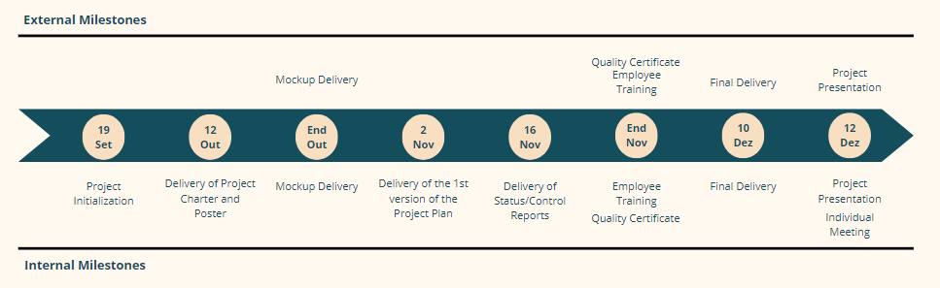

| Figure 3: Milestones. |
| --- |

## Calculation of Estimates

Task estimates were calculated without the use of any formulas, considering that the working group already knows each other well, having worked together on several projects previously, so there is a sense of their capabilities, working methods, characteristics, and also the areas in which they feel most comfortable or have the most difficulty, thus requiring more or less time to complete. The calculation of estimates also took into account the project's time constraints, the delivery dates for deliverables and the project deadline. In short, the time required for each task was estimated based on the experiences of previous projects of the same nature among the various members of the team. All the work defined for the development of each task is presented in section 4.B.

## Critical Path Management

The critical path is a set of tasks that are linked and directly affect the project's completion date. If any of these tasks is behind schedule, the whole project is behind schedule.

| Table 7 : Critical Path. | | |
| --- | --- | --- |
| **WBS** | **Activity** | **Duration** |
| **1.1** | **Initiation** |  |
| 1.1.3 | Identification of Key Requirements | 8 hours |
| **1.2** | **Planning** |  |
| **1.2.1** | **Scope Planning** |  |
| 1.2.1.1 | Framework | 4 hours |
| 1.2.1.2 | Defining the purpose of the project | 4 hours |
| 1.2.1.4 | Drawing up the list of requirements | 4 hours |
| **1.2.2** | **Stakeholder Planning** |  |
| 1.2.2.3 | Drawing up a strategy for dealing with stakeholders | 8 hours |
| 1.2.2.4 | Creating a work-package perspective | 8 hours |
| **1.2.3** | **Time Planning** |  |
| 1.2.3.1 | Drawing up a list of activities to be carried out | 4 hours |
| 1.2.3.2 | Drawing up a schedule | 4 hours |
| 1.2.3.6 | Drawing up the critical path | 8 hours |
| **1.2.4** | **Cost Planning** |  |
| 1.2.4.4 | Determining the budget | 12 hours |
| **1.2.6** | **Quality planning** |  |
| 1.2.6.3 | Review documentation | 8 hours |
| **1.4** | **Execution** |  |
| **1.4.2** | **Mobile App** |  |
| **1.4.2.1** | **Development of the 1st Version of the APP** |  |
| 1.4.2.1.1 | Database creation | 40 hours |
| 1.4.2.1.2 | Platform development | 71 hours |
| 1.4.2.1.3 | Quality testing | 22 hours |
| **1.4.2.2** | **Final Product Development** |  |
| 1.4.2.2.1 | Improvement plan | 8 hours |
| **1.5** | **Finalization** |  |
| 1.5.1 | Preparation of the user manual | 4 hours |
| 1.5.2 | Drawing up the maintenance manual | 4 hours |
| 1.5.3 | Obtaining the quality certificate | 5 hours |
| 1.5.7 | Final presentation | 20 min |

## Description of Reserve Calculation

The critical chain method was used to define which activities would have reserves (reserves were only defined for critical path activities).

The PERT method was used to calculate these reserves.

| Table 8: Time PERT Calculation. | | | | | |
| --- | --- | --- | --- | --- | --- |
| **Activity** | **Probable Estimate** | **Probable Estimate** | **Pessimistic Estimate** | **PERT** | **Reserve** |
| **Initiation** |  |  |  |  |  |
| Identification of Key Requirements | 4,00 | 8,00 | 20,00 | 9,333 | 1,333 |
| **Planning** |  |  |  |  |  |
| **Scope Planning** |  |  |  |  |  |
| Framework | 2,00 | 4,00 | 10,00 | 4,667 | 0,667 |
| Defining the purpose of the project | 2,00 | 4,00 | 8,00 | 4,333 | 0,333 |
| Drawing up the list of requirements | 2,00 | 4,00 | 10,00 | 4,667 | 0,667 |
| **Stakeholder Planning** |  |  |  |  |  |
| Drawing up a strategy for dealing with stakeholders | 5,00 | 8,00 | 15,00 | 8,667 | 0,667 |
| Creating a work-package perspective | 5,00 | 8,00 | 15,00 | 8,667 | 0,667 |
| **Time Planning** |  |  |  |  |  |
| Drawing up a list of activities to be carried out | 2,00 | 4,00 | 10,00 | 4,667 | 0,667 |
| Drawing up a schedule | 2,00 | 4,00 | 20,00 | 6,333 | 2,333 |
| Drawing up the critical path | 4,00 | 8,00 | 14,00 | 8,333 | 0,333 |
| **Cost Planning** |  |  |  | 0,000 | 0,000 |
| Determining the budget | 6,00 | 12,00 | 20,00 | 12,333 | 0,333 |
| **Quality planning** |  |  |  | 0,000 | 0,000 |
| Review documentation | 6,00 | 8,00 | 25,00 | 10,500 | 2,500 |
| **Execution** |  |  |  |  |  |
| **Mobile App** |  |  |  |  |  |
| **Development of the 1st Version of the APP** |  |  |  |  |  |
| Database creation | 20,00 | 40,00 | 65,00 | 40,833 | 0,833 |
| Platform development | 50,00 | 71,00 | 95,00 | 71,500 | 0,500 |
| Quality testing | 15,00 | 22,00 | 30,00 | 22,167 | 0,167 |
| **Final Product Development** |  |  |  |  |  |
| Improvement plan | 4,00 | 8,00 | 14,00 | 8,333 | 0,333 |
| **Finalization** |  |  |  |  |  |
| Preparation of the user manual | 2,00 | 4,00 | 8,00 | 4,333 | 0,333 |
| Drawing up the maintenance manual | 2,00 | 4,00 | 8,00 | 4,333 | 0,333 |
| Obtaining the quality certificate | 2,00 | 5,00 | 10,00 | 5,333 | 0,333 |
| Final presentation | 0,167 | 0,333 | 0,500 | 0,333 | 0,000 |
| **Total** | **135,167** | **226,333** | **397,500** | **239,667** | **13,333** |

Based on Table 8, the anticipated total work hours for this project amount to approximately **239 hours and 40 minutes**.

# Project Costs

## Resource List

This resource list in Table 2 provides a budget breakdown for the project.

|  | Table 9: Perspective of Budget. | | | |
| --- | --- | --- | --- | --- |
| **Description** | | **Details** | **Justification** | **Price** |
| Human Resources | Member Salary | 4 members at 10€/hour, working 6 hours/week for 14 weeks. | Compensation for the team involved in developing the project. | 3 360,00 € |
| Traveling | Weekly travel for 14 weeks (169.2 km, €34.18/day). | Necessary for client meetings and stakeholder engagement. | 478,52 € |
| Equipment | | 4 computers | Essential tools for project work and communication. | 269,23 € |
| Meeting Room | | Rent for a conference room with projector and internet. | Necessary for team meetings and presentations with stakeholders. | 600,00 € |
| Quality Certificate | | Safety and performance audits. | To ensure compliance with technical requirements at the end of the project. | 500,00 € |
| Marketing costs | | Promotional materials | Leaflets, posters and digital marketing | 800,00 € |
| **Total** | | | | **6007,75 €** |

## Estimate Description

This budget ensures that all critical areas, including travel, equipment, team compensation, and marketing, are accounted for, providing a clear and structured financial framework for the project.

* **Human Resources:**
  + **Team Salary:** The team is composed of four members, each earning €10/hour. With each member working 6 hours per week for a 14-week project duration, the total salary cost per person is €840.
  + **Travel Costs:** The cost of each weekly trip for two team members is €34.18, which includes tolls (€3.50/day) and fuel with the help of “ViaMichelin”.
* **Equipment Costs:** Each team member uses a computer with an average cost of 1000€. To determine the value of a 4-year-old computer for this 14-week project, the straight-line depreciation method is applied, distributing the cost over the equipment's estimated 4-5 year lifespan. The remaining value is then prorated for the duration of the project.
  + Estimated useful life: 4 years.
  + Annual depreciation: 1000€ / 4 = 250€.
  + Depreciated value after 3 years: 1000€ - (3 x 250€) = 250€.
  + Weekly depreciation cost: 250€ / 52 weeks = 4.81€/week.
* **Meeting Room Rental:** The team will rent a conference room in Guimarães, which is equipped with the necessary facilities for effective project communication and client engagement. The room rental cost is €600 for the entire project duration.
* **Quality Certification:** To ensure that the project complies with safety and technical standards, a Quality Certificate audit will be conducted at the end of the project. This will cost €500.
* **Marketing Costs:** A marketing campaign will be launched at the project’s completion, including both print materials (leaflets, posters) and digital marketing efforts, with a total cost of €800.

## Reservation Description

The value of the reservation is calculated by the PERT estimative (profit margins are not accounted for).

For the pessimistic estimate, the team assumed each member would work 10 hours per week, an additional 4 hours beyond the typical workload, totaling the time required to complete the project. This estimate also factored in 16 trips with a longer journey cost of €0.21 per kilometer, and the need for five computers.

In the optimistic scenario, assuming everything goes better than planned, the cost of human resources was reduced based on a decrease in weekly working hours to 4 hours, covering both execution and management. For travel, the variation factor included different routes at a lower cost of €0.18 per kilometer, while the equipment needs were adjusted to require only three computers.

| Table 10: PERT Estimation. | | | | | |
| --- | --- | --- | --- | --- | --- |
| **Description** | **Optimistic Cost** | **Probable cost** | **Pessimistic cost** | **PERT** | **Reservation** |
| Member Salary | 2 240,000 € | 3 360,000 € | 5 120,000 € | 3 466,667 € | 106,667 € |
| Traveling | 402,640 € | 478,520 € | 532,560 € | 474,880 € | 3,640 € |
| Equipment | 201,923 € | 269,231 € | 336,538 € | 269,231 € | 0,000 € |
| Room | 140,000 € | 600,000 € | 3 400,000 € | 990,000 € | 390,000 € |
| Quality Certificate | 200,000 € | 500,000 € | 1 000,000 € | 533,333 € | 33,333 € |
| Marketing Costs | 150,000 € | 800,000 € | 1 500,000 € | 808,333 € | 8,333 € |
| **Total** | **3 334,563 €** | **6 007,751 €** | **11 889,098 €** | **6 542,444 €** | **541,973 €** |

It should be emphasized that the figures for salaries, travel and equipment are subject to IVA at the rate in vigor.

## Budget

Considering the estimated project costs along with the calculated reserves (as shown in Table 3), the total budget for this project amounts to €6549,72.

### Time Frame

The budget timeline is outlined in Table 4. The Quality Certificate and Marketing Costs are scheduled for the final week of the project, as the Quality Certificate will assess the project's outcome, and the marketing campaign will be launched upon project completion.

| Table 11: Budget Time Frame. | | | | | | | |
| --- | --- | --- | --- | --- | --- | --- | --- |
| **Week** | **Human Resources** | **Equipment** | **Meeting Room** | **Quality Certificate** | **Marketing Costs** | **Reserves Costs** | **Total** |
| 1 | 274,18 € | 19,23 € | 42,86 € |  |  | 38,71 € | **374,98 €** |
| 2 | 274,18 € | 19,23 € | 42,86 € |  |  | 38,71 € | **374,98 €** |
| 3 | 274,18 € | 19,23 € | 42,86 € |  |  | 38,71 € | **374,98 €** |
| 4 | 274,18 € | 19,23 € | 42,86 € |  |  | 38,71 € | **374,98 €€** |
| 5 | 274,18 € | 19,23 € | 42,86 € |  |  | 38,71 € | **374,98 €€** |
| 6 | 274,18 € | 19,23 € | 42,86 € |  |  | 38,71 € | **374,98 €** |
| 7 | 274,18 € | 19,23 € | 42,86 € |  |  | 38,71 € | **374,98 €** |
| 8 | 274,18 € | 19,23 € | 42,86 € |  |  | 38,71 € | **374,98 €** |
| 9 | 274,18 € | 19,23 € | 42,86 € |  |  | 38,71 € | **374,98 €** |
| 10 | 274,18 € | 19,23 € | 42,86 € | 500€ |  | 38,71 € | **874,98 €** |
| 11 | 274,18 € | 19,23 € | 42,86 € |  |  | 38,71 € | **374,98 €** |
| 12 | 274,18 € | 19,23 € | 42,86 € |  |  | 38,71 € | **374,98 €** |
| 13 | 274,18 € | 19,23 € | 42,86 € |  |  | 38,71 € | **374,98 €** |
| 14 | 274,18 € | 19,23 € | 42,86 € |  | 800 € | 38,71 € | **1174,98 €** |
| **Total** | **3 360,00 €** | **269,23 €** | **600,00 €** | **500,00 €** | **800,00 €** | **541,97** | **6 440,21 €** |

The Time Perspective (Graph 1) shows the distribution of the project budget over the various weeks defined for its development.

| Graph 1: Time perspective. |
| --- |
| Points scored |

### 

### Work-Package Perspective

| Graph 2: Work-Package Perspective. |
| --- |
| Points scored |

# Attachments

## Product Breakdown Structure

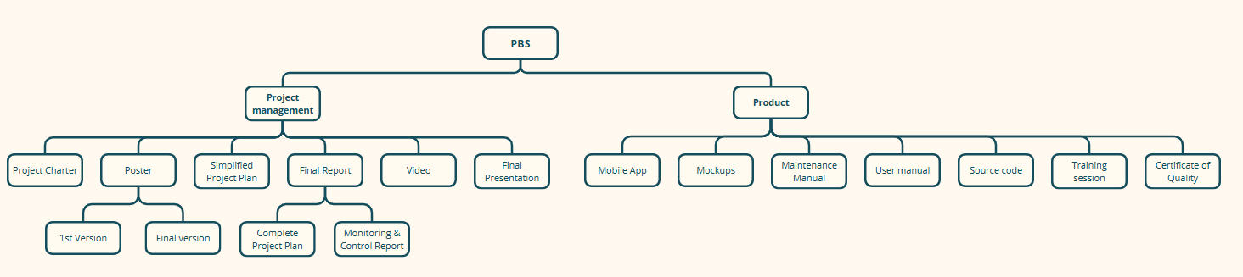

## Work Breakdown Structure

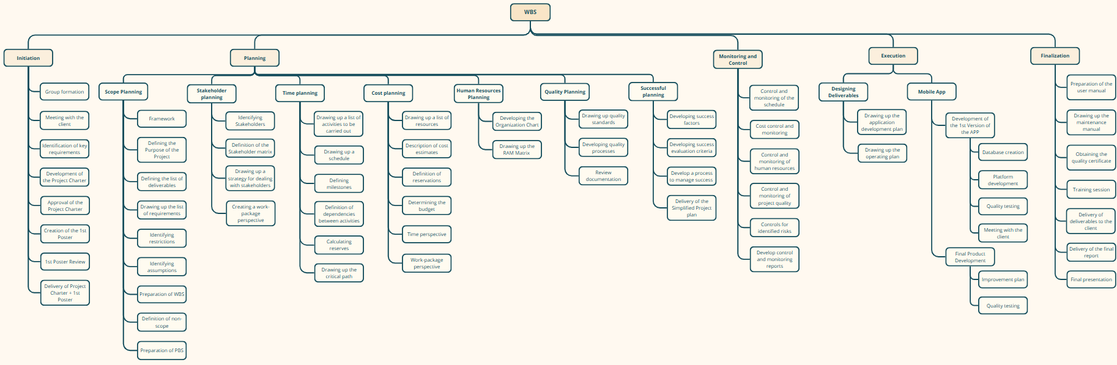

## R(e)BS

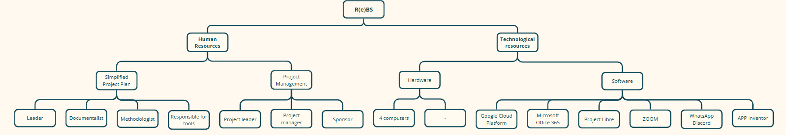

## Gantt Diagram

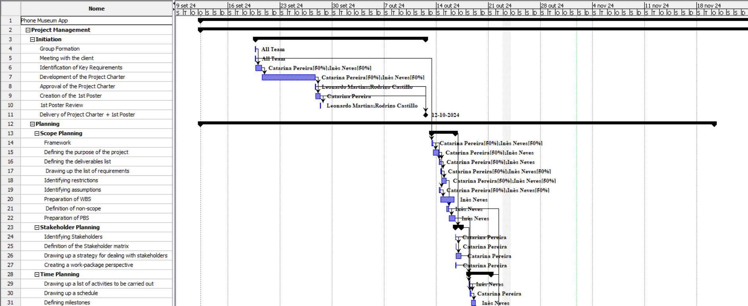

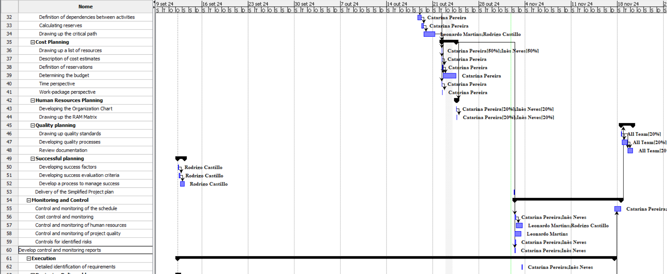

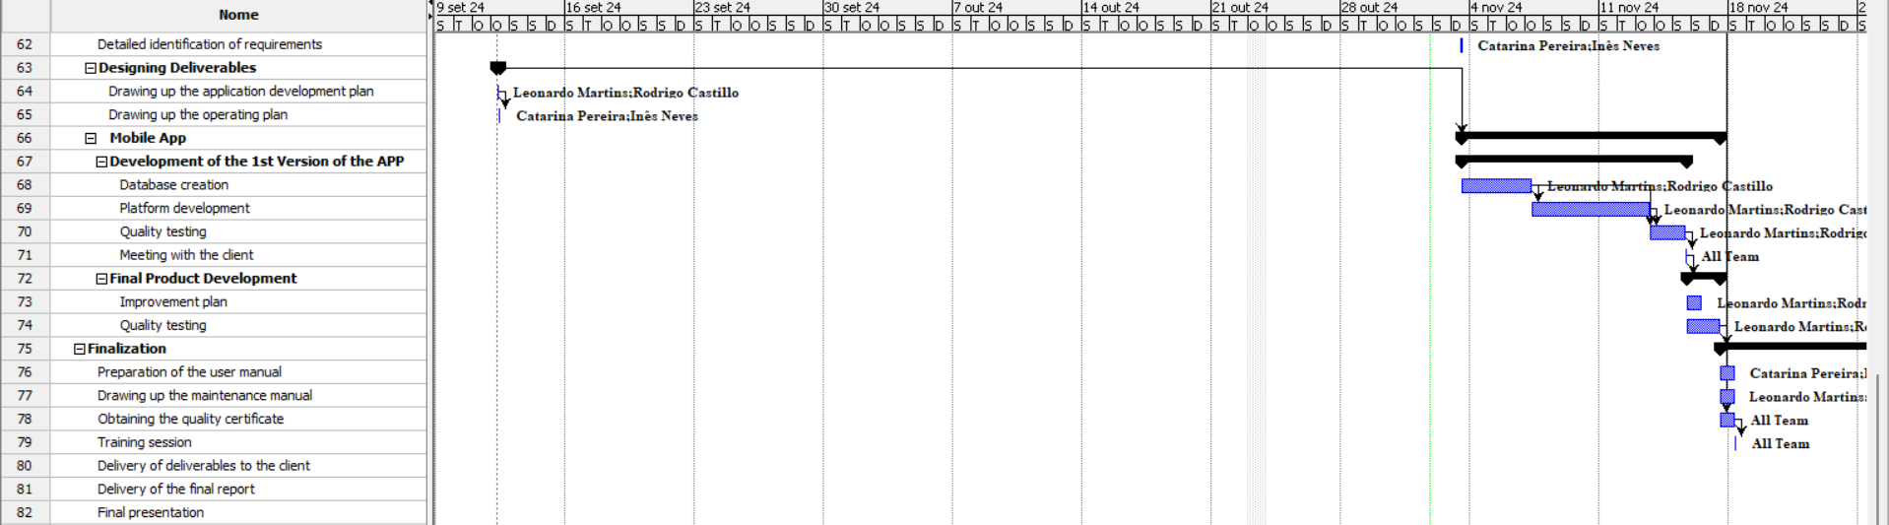

# Declaration of Knowledge

The undersigned parties declare that they have read and fully understand the contents of this document. By signing it, they confirm that they are aware of all its terms, responsibilities and commitments, and assume the fulfillment of their duties as described in this document.

Date: ___________________

Team Leader

Sponsor